Online Personal Counselling System

Table of contents :

Table of Contents

Table of Contents ii

1. Introduction 1

2. functional reqirements 2

2.1 User functional reqirements 2

2.2 System functional reqirements 2

3. Non functional Requirements 3

3.1 look and feel 3

3.2 usability&humantiy 3

3.3 performance 3

3.4 maintainbility 3

3.5 cultural…………………………………………………………………………………………………………………………..3

3.6 legal …………………………………………………………………………………………………………………………3

3.7 security……………………………………………………………………………………………………………………….3

4. Diagrams 4

4.1 usecase diagram 4

4.2 usecase description 4

4.1 ER diagram 4

4.2 database tables diagrams 4

4.1 class diagram 4

4.2 activity diagram 4

Introduction to the project:

In order to improve the facilities related to counselling process, many other virtual counselling schemes came into actuality, which provisions the students in getting essential help about the educational procedures of universities and colleges. Counselling is the process that includes different types of activities such as guiding students towards colleges and universities, supporting them to register with their courses, providing full guidance in getting the information related to their college registration process. This online counselling system even gives great support to universities and colleges through which they can totally reduce the paper usage for counselling and guiding the students towards their university courses. Basically this software includes three different modules in which universities can manage their college records, student’s records as well as counselling sections.

Functional Requirements:

Firstly: User requirements

1. The Counselling System helps students to show all information about faculty, record courses and show their grades and contact with Officials.

2- The Counselling System helps university can manage their college records, student’s records as well as counselling sections and can totally reduce the paper usage .

System Requirements:

* 1. in September students can registrations in the system.
  2. in October students can records courses and choose favorites class.
  3. students can contact with Officials and show their cv.
  4. students know all information about semester’s.
  5. in January students know time of exomes and their tables.
  6. students know their results and make a complaint.
  7. Faculty members can fully record data on the system in order to avoid mistakes, save time and effort, and also add all college records.
  8. The university can amend the academic courses by adding some courses, removing some of them, or adding new departments.
  9. The system will help the university in counting the number of students, determining the start and end dates of the semester, and easily determining the dates of the exams.
  10. Communicating information about the semester and the course plan in an easy and guaranteed way through the system.
  11. Facilitate the search for students and courses.

Non Functional requirements :

(1Look-and-Feel Requirements :

1- The system shall use a large range of exciting sounds.

2-The system should use a lot of animation.

3- The system shall use a lot of color.

(2Usability & Humanity requirements :

1- The system shall be easy to use by member and should be organized in such away users error should be minimized .

2-The search for college or university should be easy should take from 10 to 30 second.

3-Easy to managing whole counseling procedure it should take 30 minute after 2 hour training .

4-Users must change the initially assigned login password immediately after the first successful login. Moreover, the initial should never be reused.

(3Performance requirements :

1-Easy to managing whole counseling procedure it should take 30 minute after 2 hour training .

2-A website should be capable enough to handle 1000 users with affecting its performance .

3-User can easy take test on general knowledge questions and select correct answer for the asked question within 20 second .

4-users and Councilor can write a feedback message to notify the admin about the working of the system take 400 M byte .

5-the system helps the university to dynamically add records to the databaseWithin 30 second .

6-Admin can add new questions by specifying their options and the correct answer within 20 second .

7-Time to restart after failure for system should be 30 second .

8- The system should keep every id and password safe and hidden .

4 ( Maintainability:

* The system shall be able to be modified to cope with minor changes to supreme council of universities.
* The system shall be able to handle more than 5000 users at the same time within the first year after its publishing.
* The system should be able to support another language with its mother language within one year of publishing .
* The system may be require to be temporarily shutdown and new modules as (ex: php classes ) to be added to the system or it may require a minor update in its graphical design (ex: html – css modules) .

5) Cultural requirements:

* The language that used in the interfaces of the system shall be polite and formal.
* The system shall not use any terms that may harm any one on the planet.
* The system shall use English language in its interfaces.
* System shall not display any violence symbols or words in its interfaces.

6) Legal Requirements:

* The system shall follow restrictions and constraints of the supreme council lf universities.
* The system shall obey to the privacy policy and terms for all users.

7) Security Requirements:

* The system should distinguish between authorized and non-authorized users.

Ex: student only cannot change his grades but only can view it .

* The system shall maintain information securely and ensure that it is only accessed by authorized users.

Ex: Counselor cannot view all information about the student but Admin only can do this.

* The system shall provide a facility for users to request personal information and request changes to that information as change password.
* The system shall only allow the transmission of personal users information only to admin and to the user itself.

The diagrams :

1- Use case diagram :

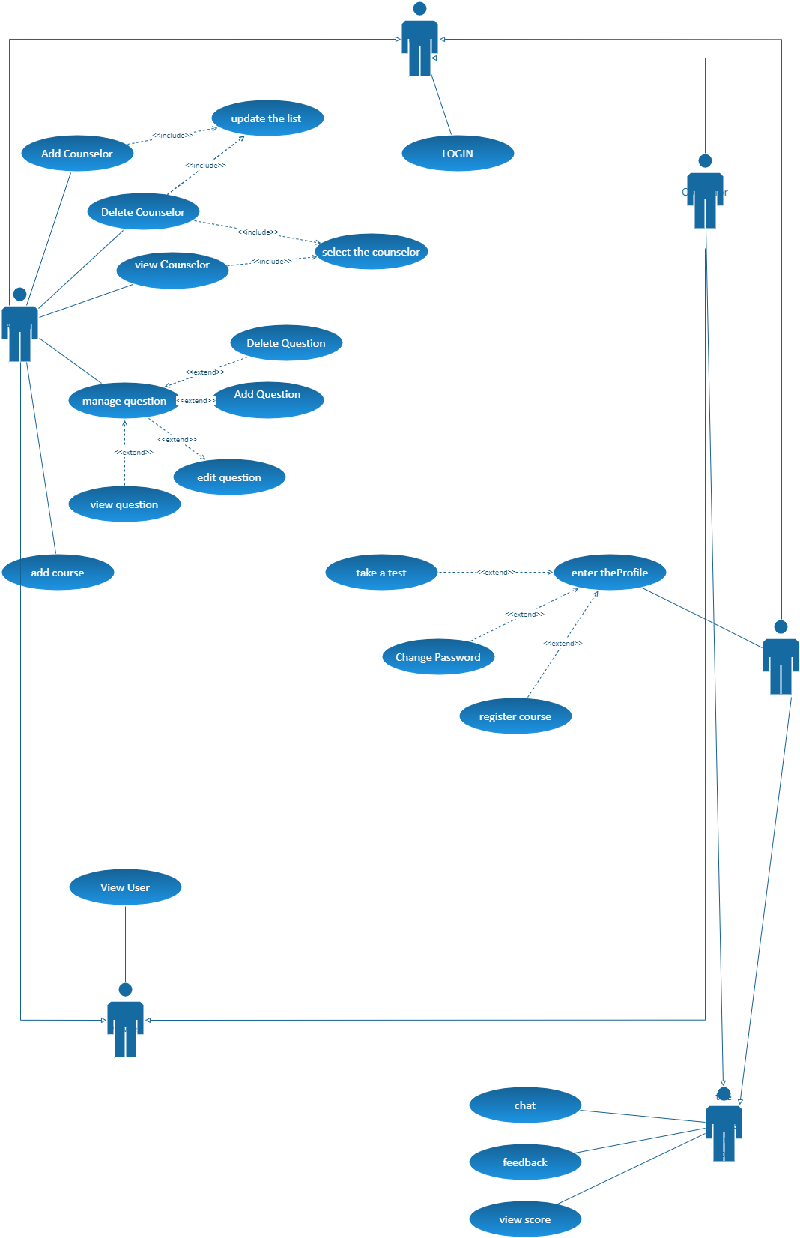

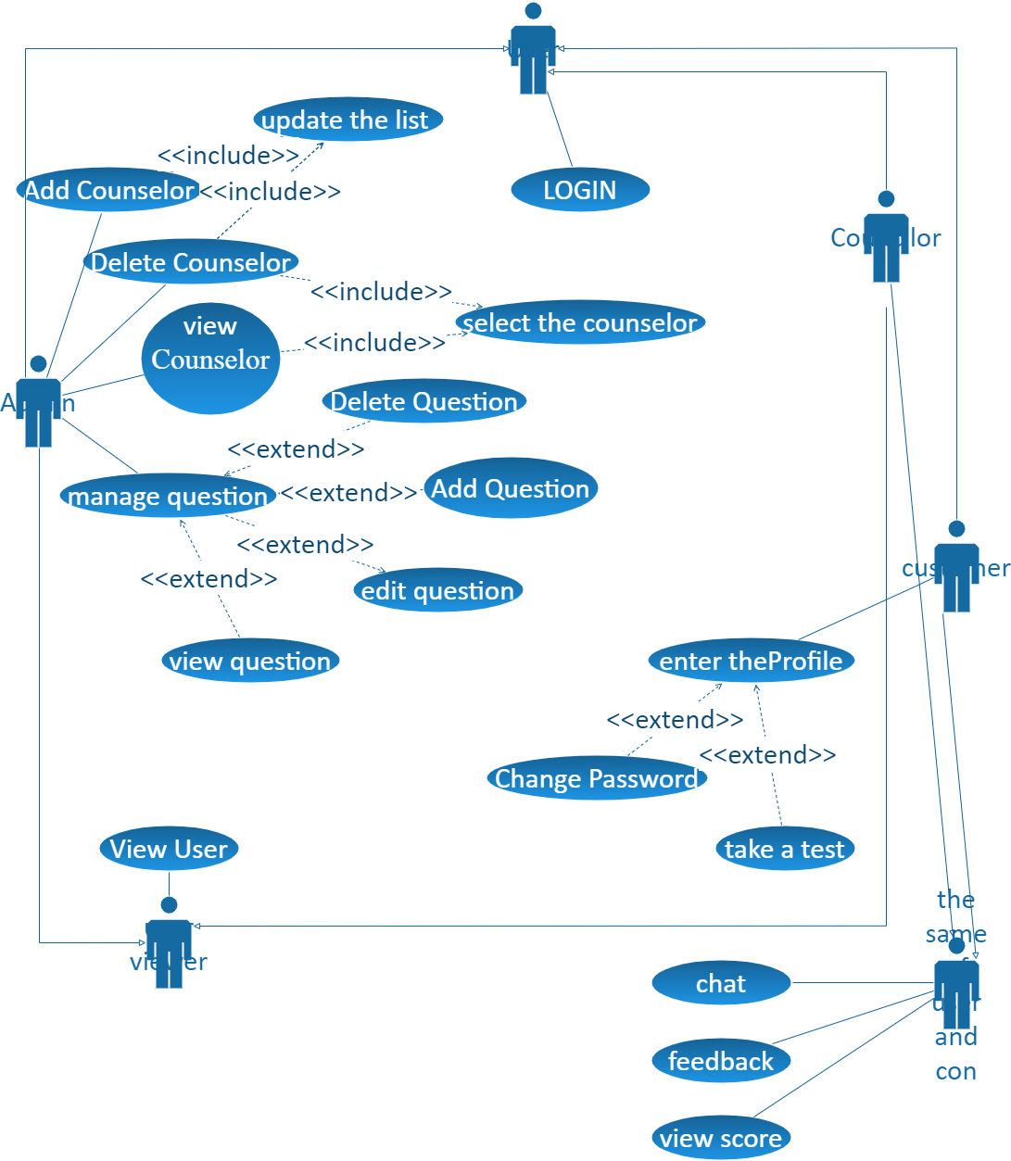

Use case description:

Add counselor :

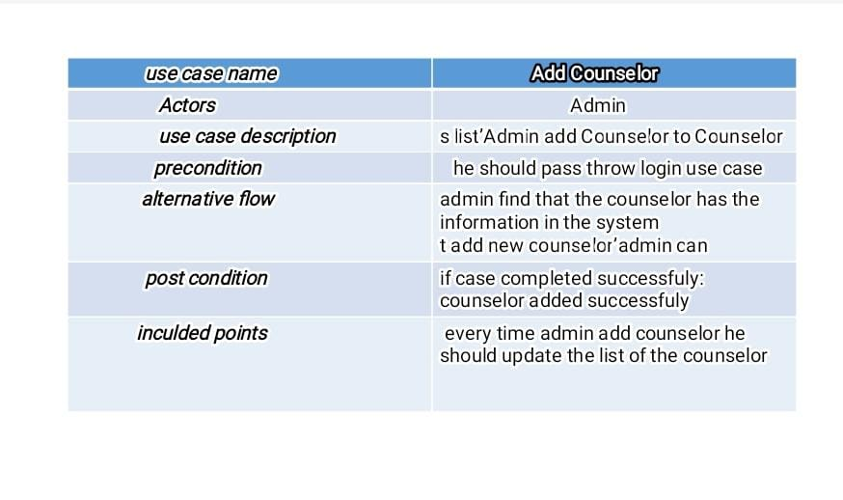

Delete counselor :

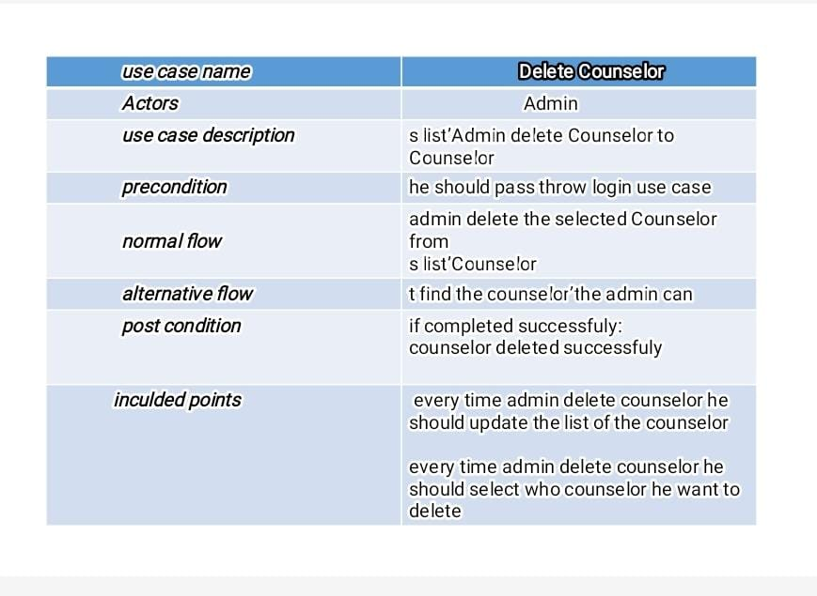

Enter profile :

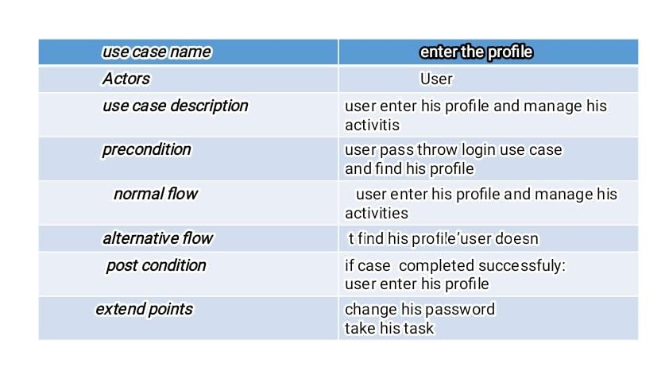

Feedback :

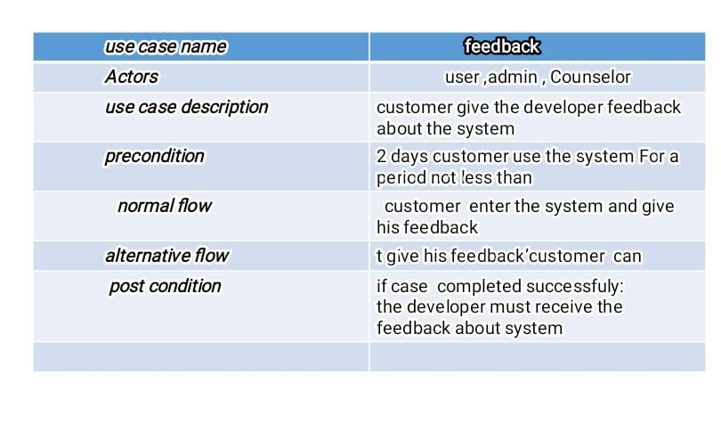

Login :

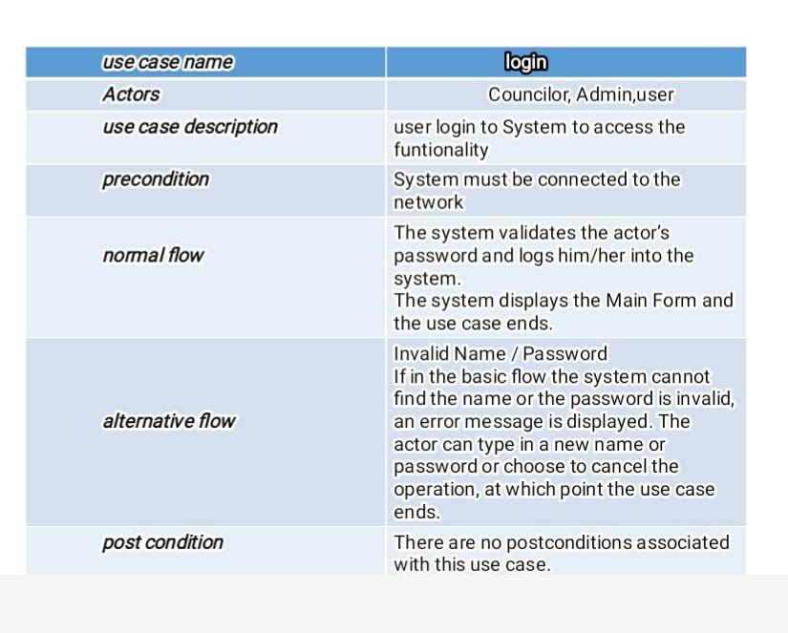

Manage question :

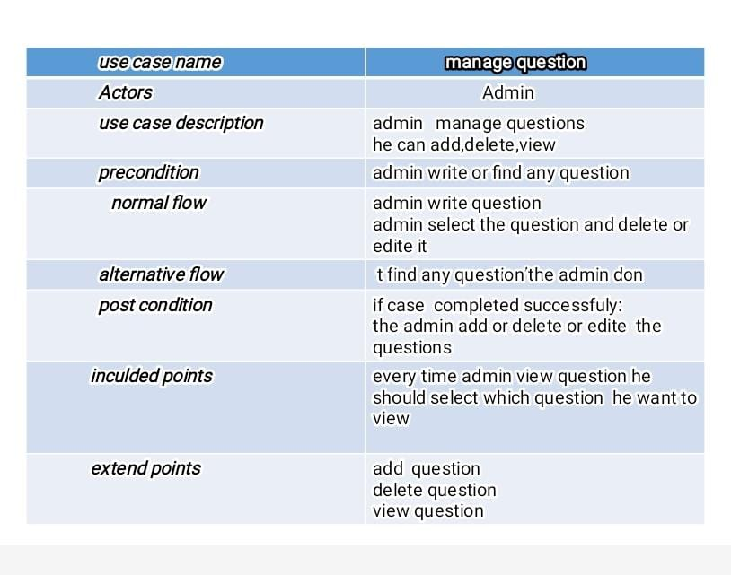

View counselor :

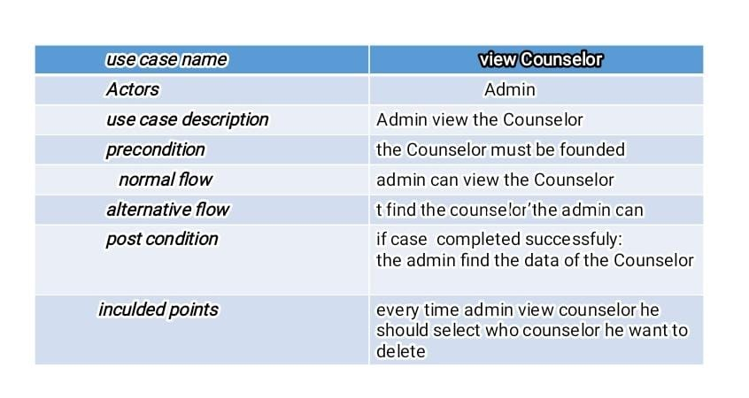

View score :

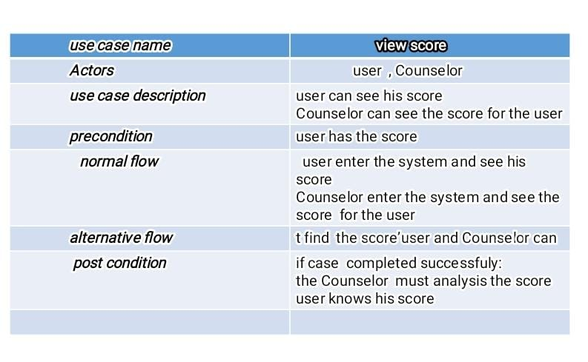

View user :

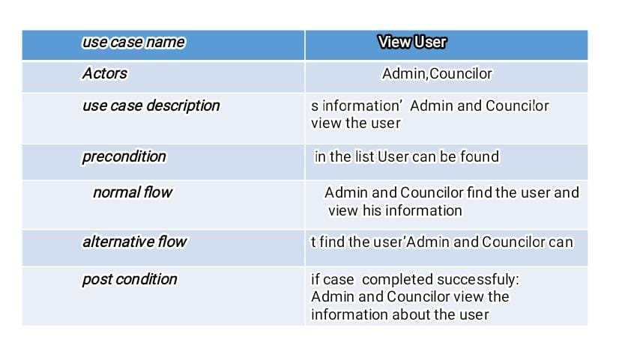

2) Database diagrams :

a) ER diagram :

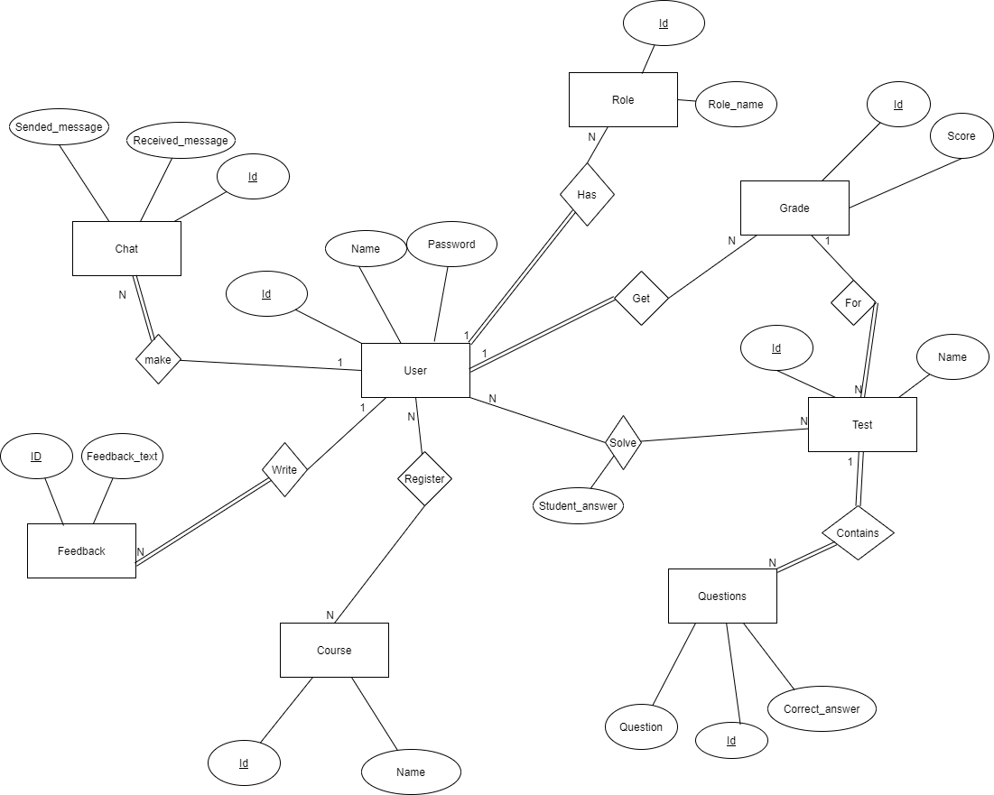

b) database tables diagram :

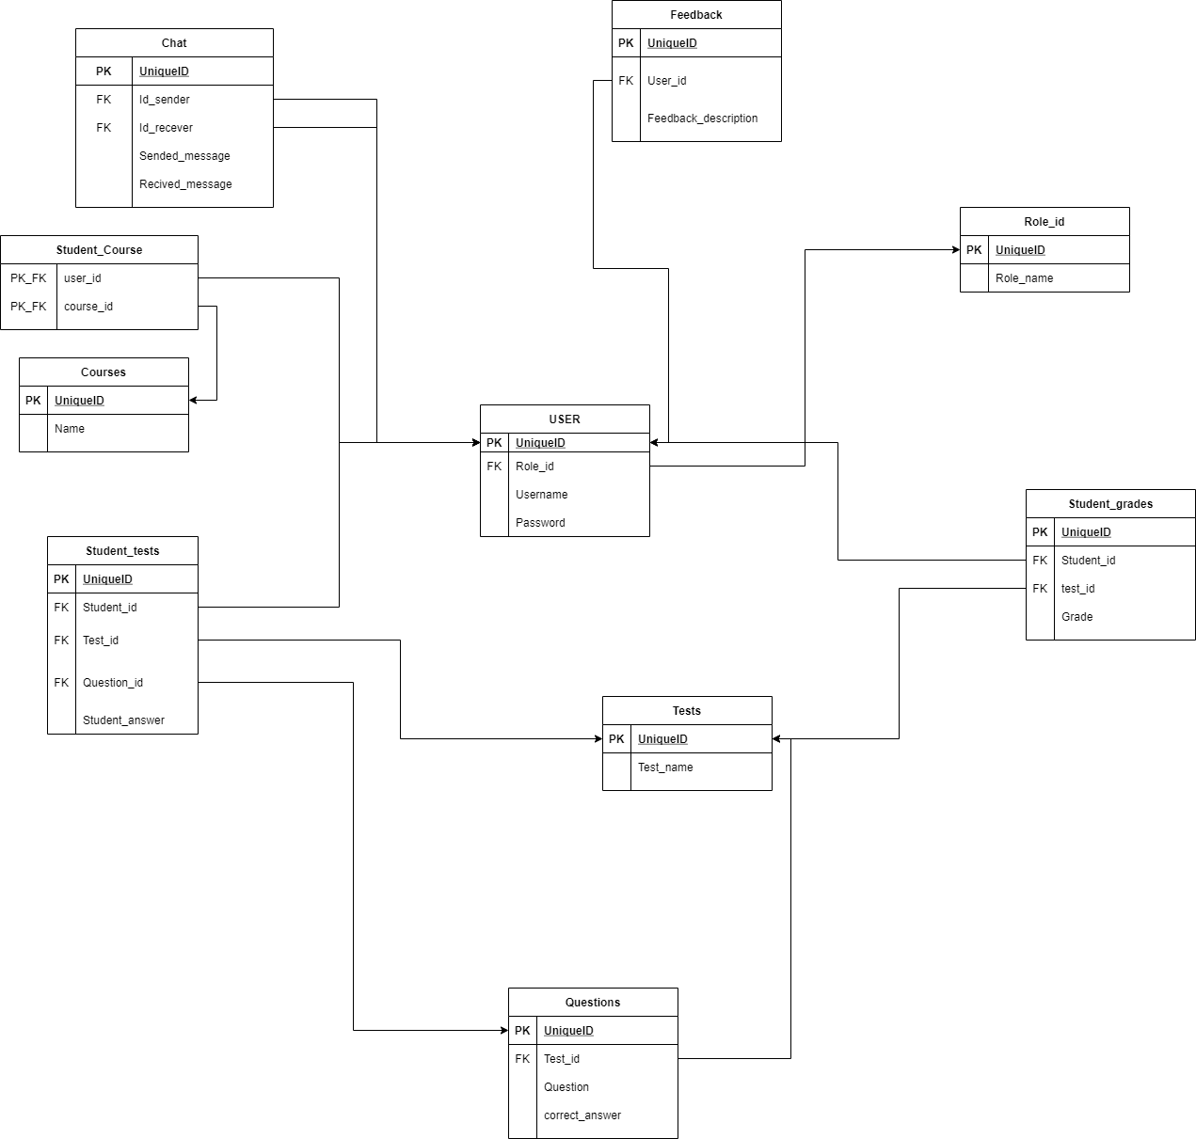

3) Class diagram :

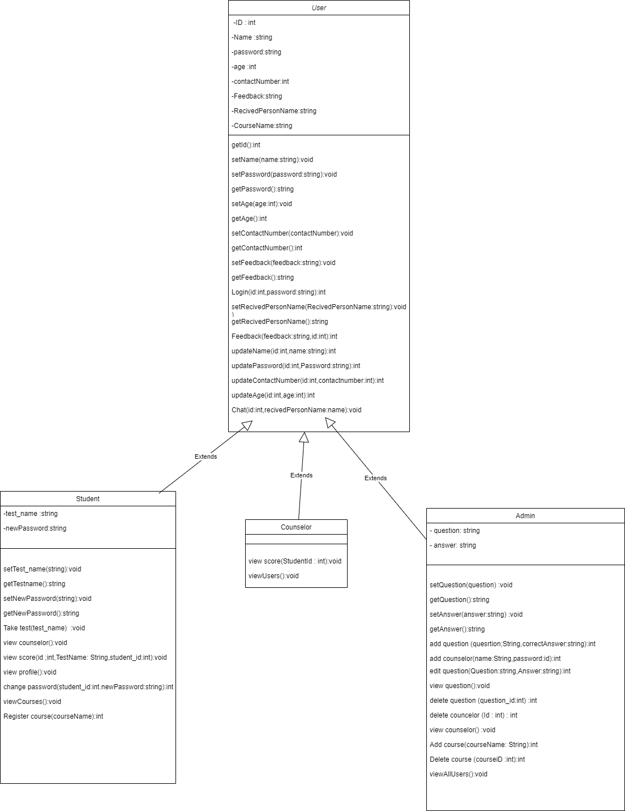

4) Activity diagram : a) login as councelor

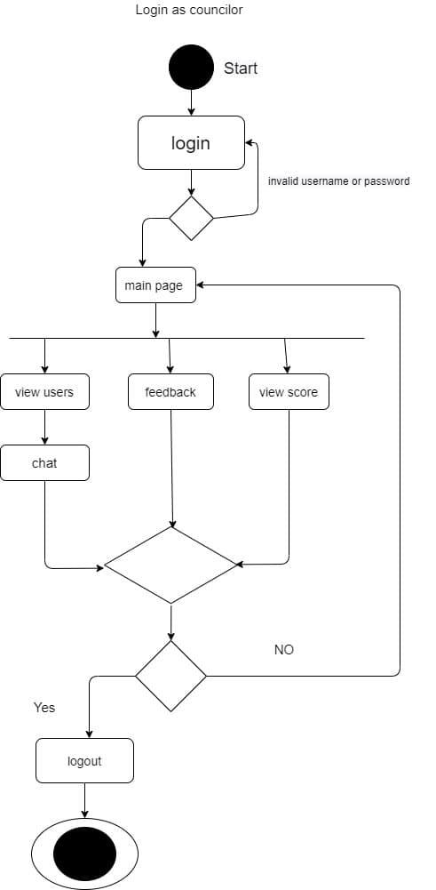

Login as Admin :

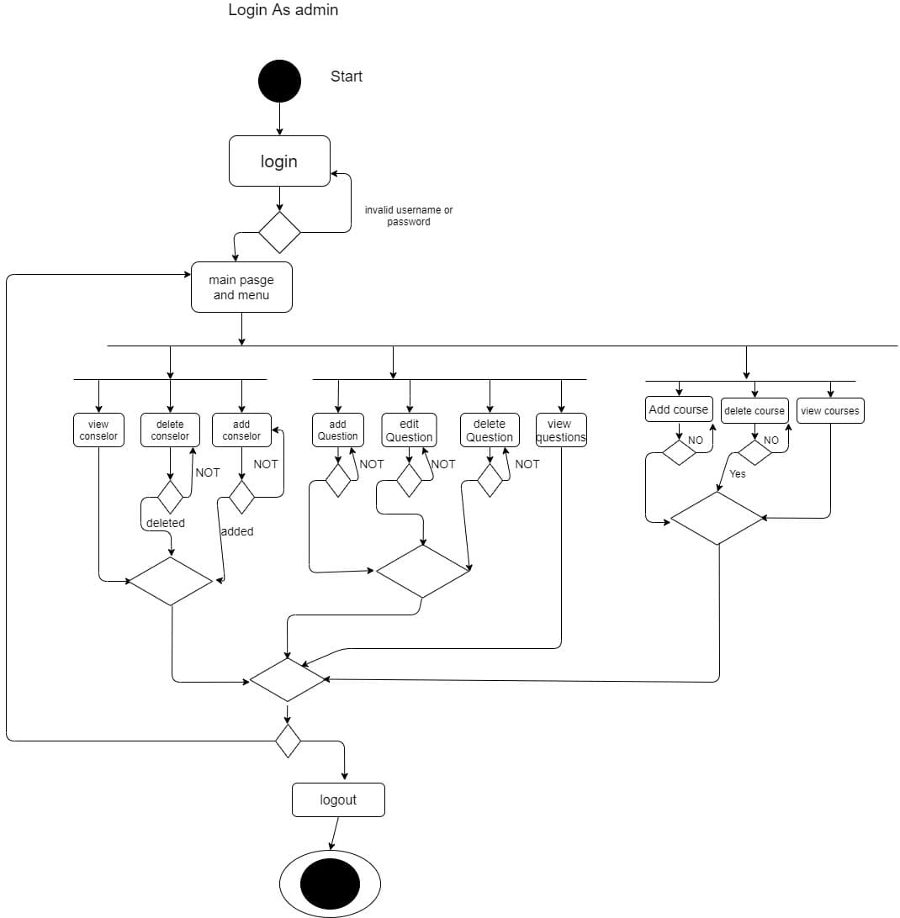

Login as User :

